**Observation**

Inspection was undertaken at the subject property in the presence of the Insured to which the following was noted:

1. In schematically illustrating the damaged areas affected by the vehicle impact, we provided **Figure 2** below highlighting the elements and areas of sustained vehicle impact damage.

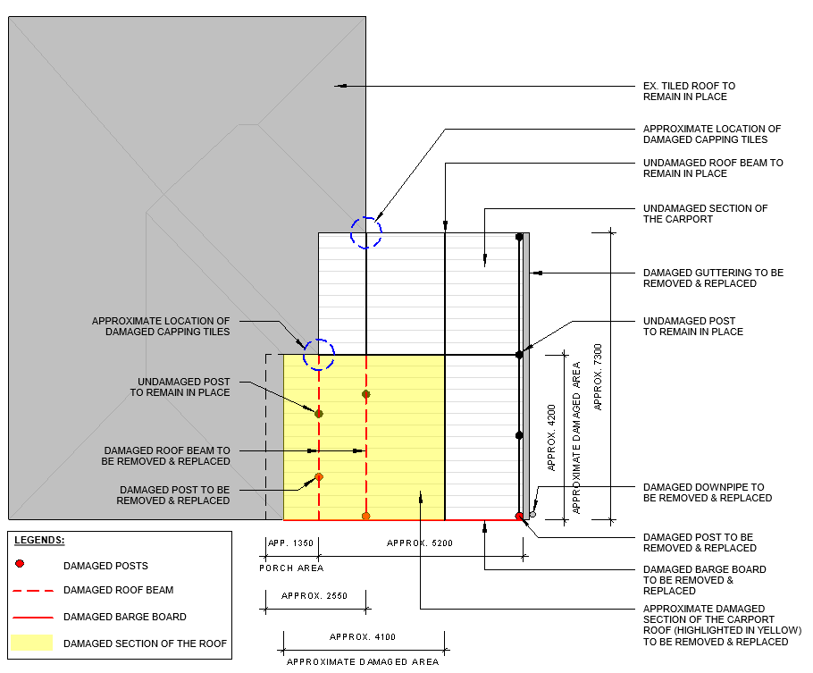

Figure 2- *Schematic Floor Plan of the Subject Carport Illustrating the Approximate Locations of the Sustained Vehicle Impact*

1. We noted the subject damaged carport has been constructed of a timber framed roof and number of scaffold tubes as post supporting a Trimdek metal sheeted roof. **Image 2**
2. We observed that the eaves gutter of the main dwelling about the south eastern alignment has been removed in facilitating the installation of the aforementioned attached carport. **Image 7**
3. No transition flashing was noted between the attached carport and the tiled roof of the main dwelling. **Images 10-11**
4. From our inspection, we confirm that the subject carport has been poorly constructed, not complying with NCC BCA 2019 and relevant Australia Standards.
5. As such, in order to provide warrantable repairs, we advise that the entire carport is to be removed and replaced; as such, a structural engineer is to be engaged to redesign the subject carport in accordance with the NCC BCA 2019 and current Australian Standards.

## External Area

1. We noted three (3) of scaffold steel posts about the front section of the carport have been damaged and rotated as a result of the subject vehicle impact. **Images 2-5**
2. However, no evidence of lateral displacement was identified within the entire carport structure (only localised movement to the damaged posts at front of the carport); as such the remaining steel posts can remain in place. **Images 2-5**
3. Damage to the roof framework about the front section of the carport inclusive of Trimdek metal roof sheeting, timber roof beams, barge board and purlins was noted, consistent with the experience vehicle impact. **Images 6-8**
4. We observed that the eaves gutter and downpipe about the eastern alignment of the carport has been damaged, consistent with the experience vehicle impact. **Image 9**
5. Damage to the hip roof capping tiles about the south eastern alignment of the dwelling adjacent to the carport area was identified, consistent with the vibration from the occurred vehicle impact. **Images 10-11**
6. We also noted the hip roof capping tiles about the south western corner of the property has been damaged; however, given the location of the subject defect, in our opinion, it should be considered as pre-existing and inconsistent with the subject vehicle impact. **Image 12**
7. Localised damage to the corner of the Pebblecrete slab within the porch area was noted, consistent with the experienced vehicle impact. **Images 4-5**
8. No other external damage to the main dwelling inclusive of, eaves soffit lining and weatherboard cladding was identified. **Images 4-7**
9. At the time of our inspection, we were unable to inspect the roof framework of the main dwelling adjacent to the carport area (direct vehicle impact location); however, no distress or movement within the eaves soffit lining was noted to suggest any structural damage to the roof framework of the main dwelling. **Image 7**
10. Displacement, damage and rotation within the left-hand side leaf of the steel entry gate was identified, consistent with the occurred vehicle impact. **Image 13**

## Internal Area

1. Crack damage to the ceiling lining and skirting within the living room was noted, consistent with the vibration from the experienced vehicle impact. **Image 15**
2. We also noted the architrave about the entry door has been damaged, consistent with the vibration from the experienced vehicle impact. **Images 16-17**

**Discussion**

NA

**Conclusion**

Identified damage detailed within the body of this report is consistent with the experienced vehicle impact.

Furthermore, in our opinion, only the front section of the garage has been displaced and rotated as a result of the direct vehicle impact; however, given the carport structure has been attached to the main dwelling, the imposed force from the vehicle impact has been dissipated by the main dwelling structure which prevented the displacement of the entire carport structure.